**5.1 Building Pipelines In Jenkins**

This section will guide you to:

* Build multibranch pipelines in jenkins

This lab has two sub-sections, namely:

5.1.1 Configuring Pipeline plugin for Jenkins

5.1.2 Creating a Pipeline

**Step 5.1.1:** Configuring Pipeline plugin for Jenkins

* Go to Jenkins **dashboard**.
* Click on ***Manage Jenkins*** and select ***Manage Plugins*.**

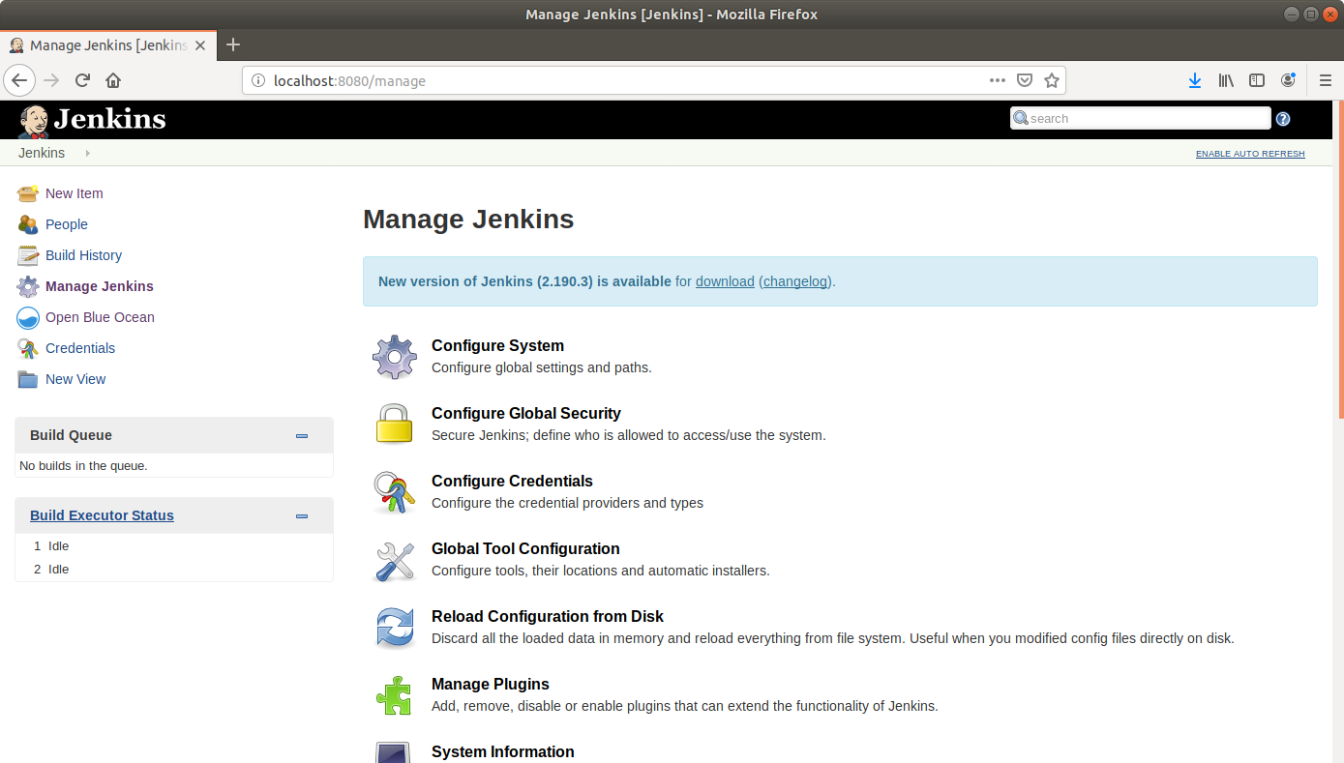

* Under the ***Available*** tab, select ***Pipeline***.
* Click on ***Install without restart*** and the plugin will be installed.
* Click ***Save***.

**Step 5.1.2:** Creating a Pipeline

* Go to Jenkins **dashboard**.
* Click on ***New Item***.
* 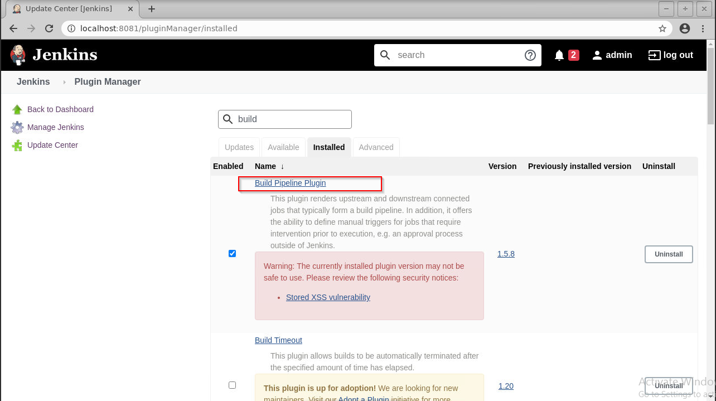Enter a **name** for your build job.
* Select **Pipeline**as the build job type.

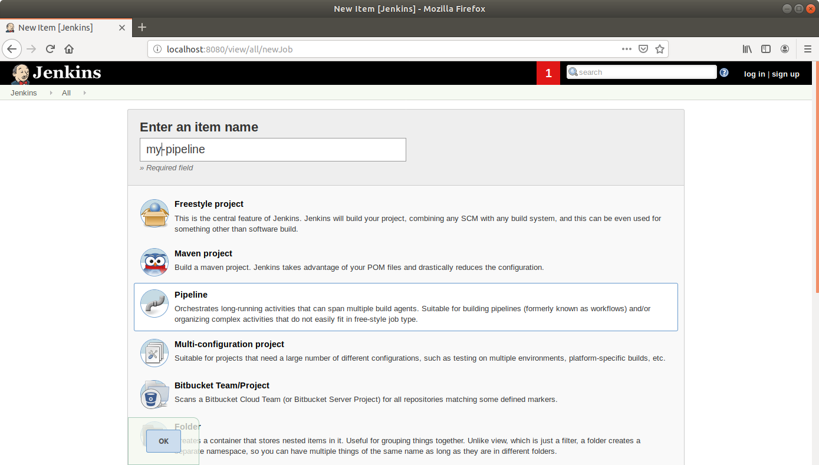

* Click OK.
* Scroll down to the Pipeline section and enter the script below:

**pipeline {**

**agent any**

**stages {**

**stage('First Stage') {**

**steps {**

**echo 'Hello World'**

**}**

**}**

**stage('Second Stage') {**

**steps {**

**echo 'Hello Again'**

**echo 'A third time Hello'**

**}**

**}**

**}**

**}**

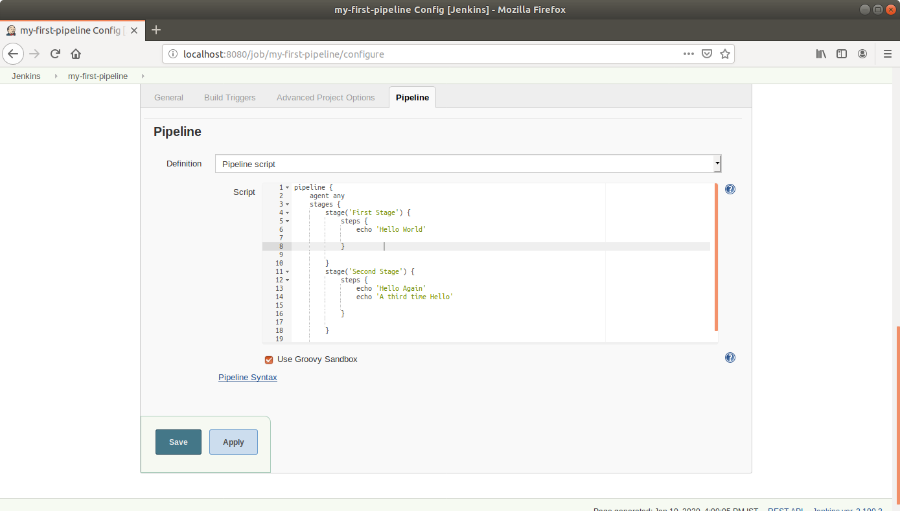

* Click **Save**.
* Click ***Build Now*** in the project window to make sure that the build works. Jenkins will now build your project.
* Click on the ***Build History***to view the build results.

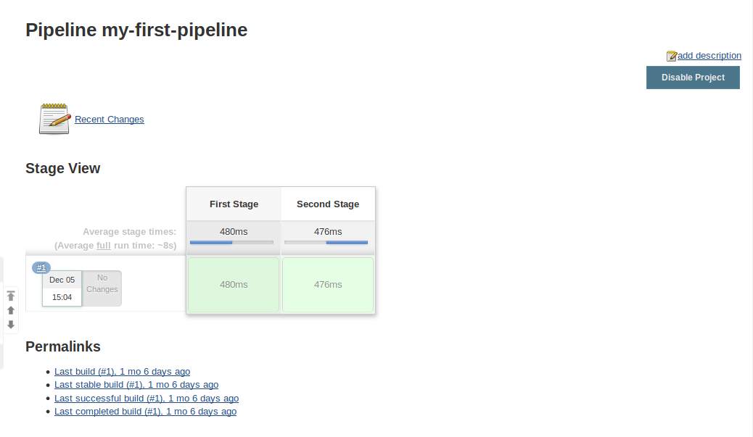

* Click on the ***Logs***to view the build logs in each stage.

